**Diagrama a bloques del sistema**

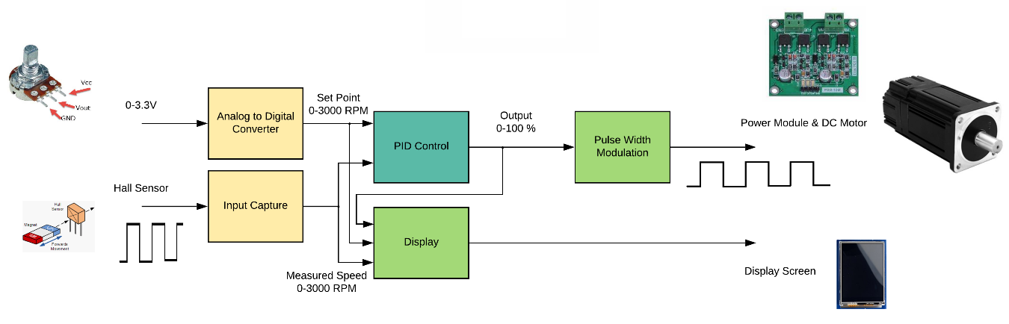

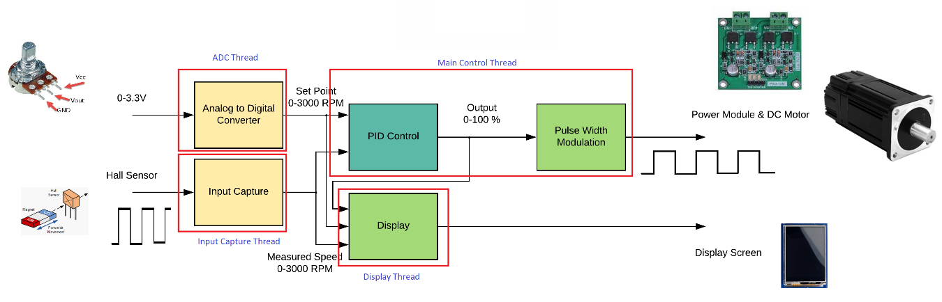**Threads Implementation**

The structure of this project consists in four threads with the following names:

* ADC Thread
* Inputs: adc data (0 - 4095)
* Outpus: set point (0 - 3000 RPM)
* Input Capture Thread
* Inputs: measured period in ticks
* Outpus: measured speed (0 - 3000 RPM)
* Main Control Thread
* Inputs: set point (0 - 3000 RPM) and measured speed (0 - 3000 RPM)
* Outpus: PWM duty cycle (0 - 100 %)
* Display Thread
* Inputs: set point (0 - 3000 RPM), measured speed (0 - 3000 RPM) and duty cycle (0 - 100 %)
* Outpus: Display control signals and values to display.

**Analog to Digital Converter (ADC HAL Module)**

* Module Name: g_adc0
* Resolution: 12 bits (0 - 4095)
* Mode: Continuous Scan
* Channel: 0
* Input Voltage Range: 0 - 3.3V

API functions used:

|  |  |
| --- | --- |
| **Function name** | **Example API Call and Description** |
| .open | g_adc.p_api->open(g_adc.p_ctrl, g_adc.p_cfg);  Initialize ADC Unit; apply power, set the operational mode, trigger sources, interrupt priority, and configurations common to all channels and sensors. |
| .scanCfg | g_adc.p_api->scanCfg(g_adc.p_ctrl, g_adc.p_channel_cfg);  Configure the scan including the channels, groups and scan triggers to be used for the unit that was initialized in the open call. |
| .scanStart | g_adc.p_api->scanStart(g_adc.p_ctrl);  Start the scan (in case of software trigger) or enable the hardware trigger. |
| .read | g_adc.p_api->read(g_adc.p_ctrl, ADC_REG_CHANNEL_13, &adc_data);  Read ADC conversion result(s). |

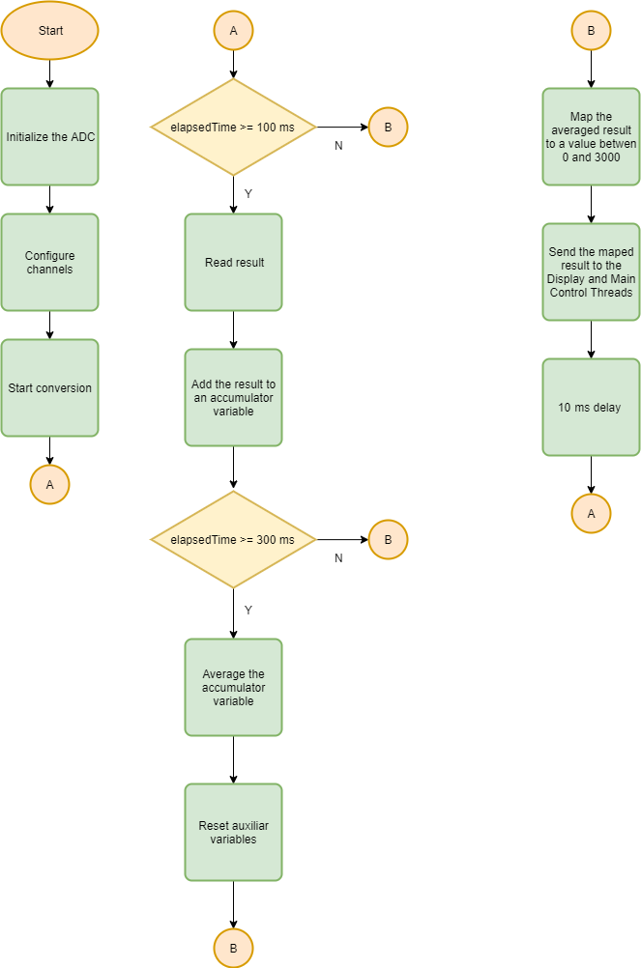

**Input Capture (Input Capture HAL Module)**

* Module Name: g_input_capture
* Mode: Period
* Signal Edge: Rising
* Repetition: Periodic
* Callback: InputCaptureCallback
* Channel: 2

API functions used:

|  |  |
| --- | --- |
| **Function name** | **Example API Call and Description** |
| .open | g_input_capture.p_api->open(g_input_capture.p_ctrl, g_input_capture.p_cfg);  Opens the Input Capture HAL and initializes configuration. |

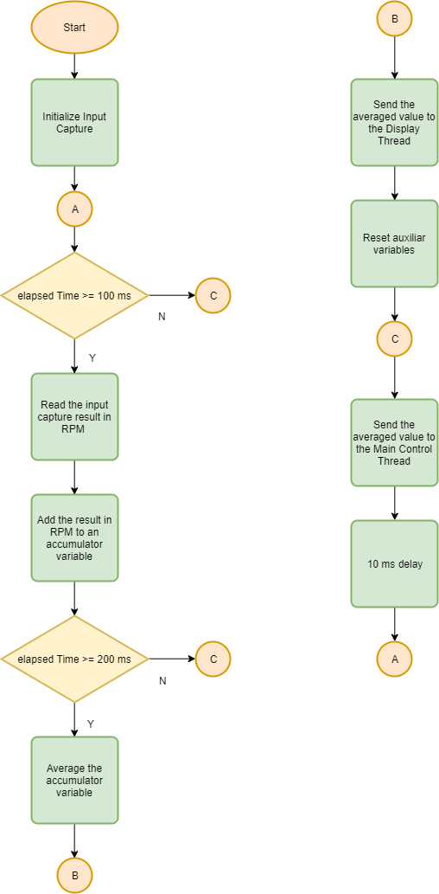

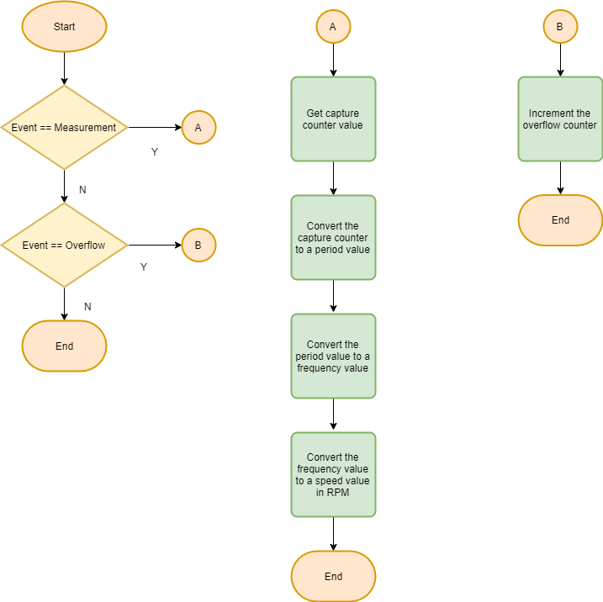

**Pulse Width Modulation (GPT HAL Module)**

* Module Name: g_timer1
* Mode: PWM
* Period Value: 1ms
* Duty Cycle Unit: Percent
* Channel: 1

API functions used:

|  |  |
| --- | --- |
| **Function name** | **Example API Call and Description** |
| .open | g_timer0.p_api->open(g_timer0.p_ctrl, g_timer0.p_cfg)  Initial configuration. |
| .start | g_timer0.p_api->start(g_timer0.p_ctrl)  Start the counter. |
| .dutyCycleSet | g_timer0.p_api->dutyCycleSet(g_timer0.p_ctrl, period, unit, pin)  Sets the time until the duty cycle expires. |

**Main Control Thread**

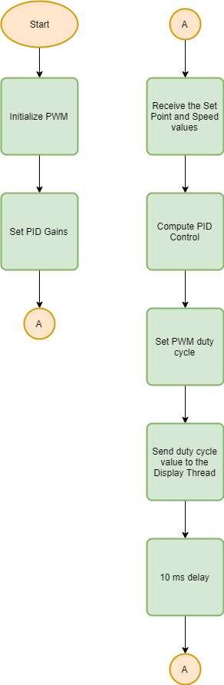

**PID Controller Pseudocode**

previous_error = 0

integral = 0

loop:

error = setpoint - measured_value

integral = integral + error * dt

derivative = (error - previous_error) / dt

output = Kp * error + Ki * integral + Kd * derivative

previous_error = error

wait(dt)

goto loop

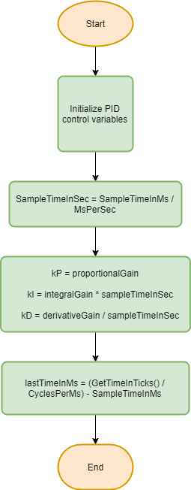

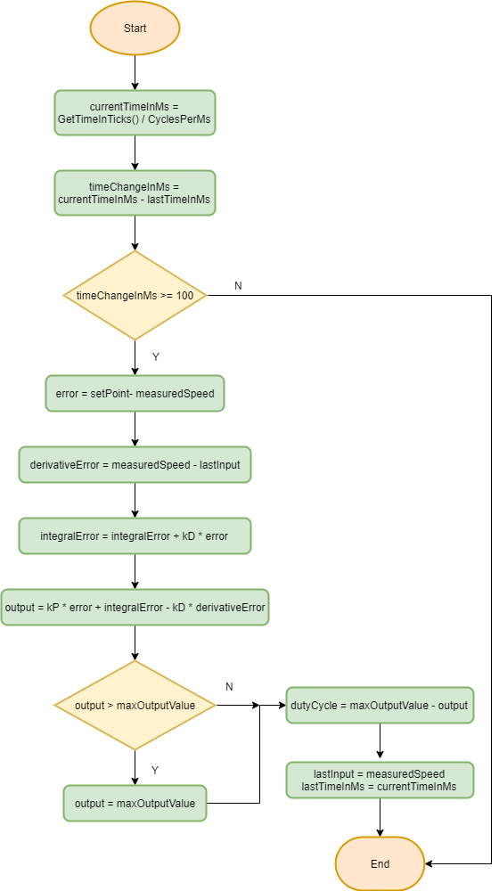

**Display Thread**

